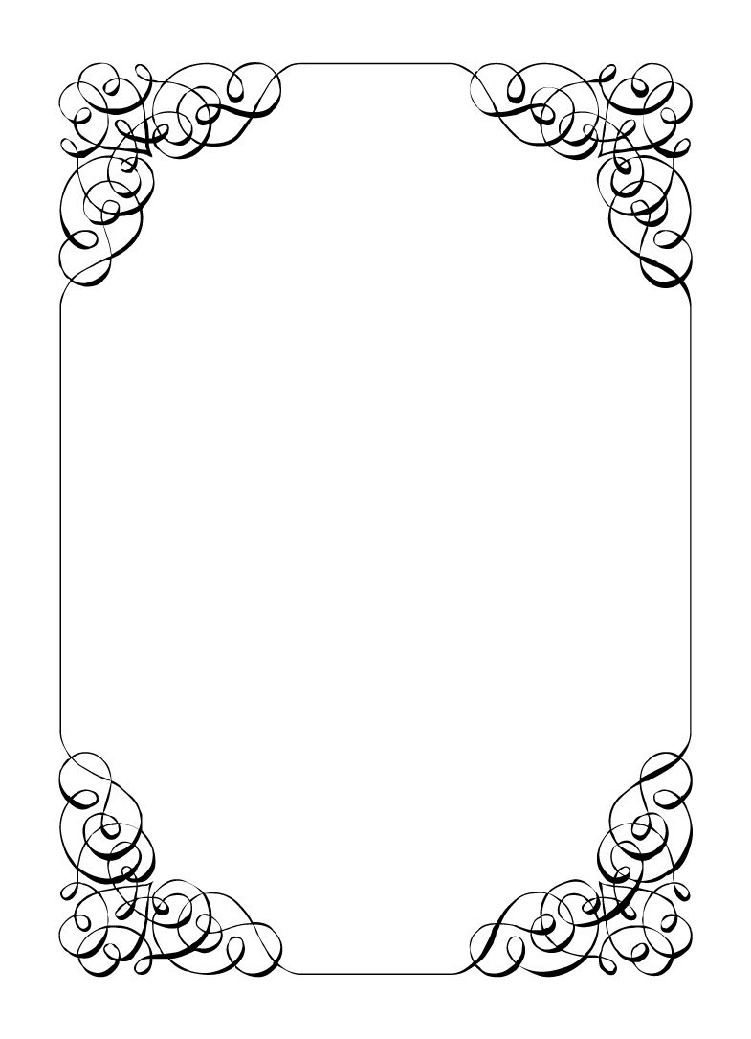

Not here to wed spiders

Wayne Marolla

*In the small town of Duck Rise, Victoria, Stralya live: BOGANS. Bogans are much like the regular folk, but drunker and louder. Some of them even fall in love. But before they settle down and poop out a mess of kids, they gotta have a wedding! Weddings are the best. Everyone gets proper plastered. Lots of kissing. Lots of drama. Fun times for all. Nothing ever goes wrong at a wedding...*  
*\*\*ominous thunder clack\*\**

Wayne Marolla

Drunk Uncle *Smart, Understanding, Trickster*

Life's a laugh, isn't it? You are just here to have a good time. Why does everyone have to be such a downer about everything all the time?  
You have paid of the staff so that this will be the best wedding ever. Now to enjoy it!  
  
**Last Night**: You were at the Bachelor party. Dave, Chad, Malibu, Sparkie, and Lucky were there. You wanted to treat everyone, so you paid for drinks on the pub crawl the whole night and fronted everyone some chips at the casino late in the night. You also arranged the hotel. You got a bit too drunk and passed out as soon as you got to the hotel. You were planning on setting everyone up with strippers at the hotel, but you never got a chance.

**Goals**

* **Get onto the wedding party:** You don't care what role you take but being in the crowd is no fun. The more roles the better
* **That ring is a family heirloom, make sure its not lost:** Find the ring and hold on to it for the ceremony. It was your Nan's!
* **Get a pre-nup signed by the Groom and whomever he marries:** Save the family money. You are loaded and you whilst you don't want anyone to know, you also don't want to lose the fortune to some floozy. Find a lawyer and get Chad to agree.
* **Hide your wealth:** Make sure no one realises or talks about that it was you that gave money to Chad or Robin.
* **Catch the bouquet:** Bit of a laugh, eh?

**Other People**

**Chad Marolla**

Ya nephew. Ya love ya nephew, don't ya? You want him to be happy, but that idiot might just sink this whole empire. Your money is worth too much to you to for him to get married without signing the pre-nup.

**Corolla Castro**

You like her well enough. She's a good fit for Chad but you just don't trust her with your money.

**Gemini Belmont**

She was responsible for losing the ring. She's a cop now so she probably thinks she's above the law. You can probably shake her down and get the ring back.

**Mercedes Bennie**

Someone who seems to understand a honest day work. Bit rough about the edges, but pobody's nerfect.

**Sparkie Castro**

You saw him weeping in his car before the start of the wedding. Seemed a bit odd to you. Maybe he just needs a tinny to calm his nerves.

**Abilities**

Use these to do things. They have a limited use, so check them off when you use them.

|  |  |
| --- | --- |
| Ability | Stumble |
| Bump into someone and show them this ability. Shuffle all your items with theirs and then get half, randomly each. |
| Usages: O O |

|  |  |
| --- | --- |
| Ability | I can see right through ya lass |
| Chat with someone who is intoxicated (or poisoned). If you manage this they must show the title (the part in bold) of their FIRST goal to you. |
| Usages: O O O |

|  |  |
| --- | --- |
| Ability | Go get me a beer |
| Interrupt another player trying to talk to you. Show them this ability. That player must then go to an Organiser, get a beer item and then hand you that item. |
| Usages: O O O |

**Secret and Information**

Your Secret contains your guilty secret, while your Information contains one or more items of information you know. Both may be affected by abilities. Your lie may need to be filled out later.

While you can show your Secret and Information to whomever you like, you will probably not want to reveal your Secret too often. (Please note that you can’t solve the crime by looking at everyone’s Secret and Information – it’s not that easy!)

|  |  |
| --- | --- |
| Secret | You are filthy rich. |

|  |  |
| --- | --- |
| Information | Your sister (Vectra) was a bit promiscuous back in the day. Got to know everyone in town real well. |

**The Organiser’s Word is Law:** The organisers are impartial. If you have a problem or want to do something unusual, see an organiser. The organiser’s power is absolute – and cannot be affected by ability cards!

**Winning and Losing:** You can achieve most of your goals simply by talking to people. The organisers will announce when the game is over. If you haven’t succeeded by that point – you’re too late! Be warned – not everyone here will want you to succeed!

**Doing Stuff:** Ordinary actions are resolved by simply carrying them out. If you want to try something unusual (such as trying to hack the pentagon), see an organiser. The organisers knows everything – and will be able to tell you the outcome of whatever it is that you are trying to do. (For example, you are trying to hack over state lines and you are caught.) Do use your imagination, though! – this is a very flexible game, and you can do all sorts of things beyond what’s listed in these rules.

**Fighting:** If an ability or item lets you hard another player, don’t just dive in! See the organisers first and tell them what you plan to do so they can oversee and give you more detailed rules if it’s necessary.

**Leaving:** You cannot leave, it is rude to leave a wedding and you are in the middle of nowhere!

**Role Cards:** If someone asks you for your role in the wedding ceremony, and you have one, you must show them all your roles.

**Item Cards:** Any items of importance within the game are represented as Item cards – and the only items that can affect the game are those detailed on the cards. If you do not have an Item card, you do not have that item with you.

**Time:** This game is played over three (ish) hours, including time for reading your character etc. There will be breaks throughout the evening! The organisers will tell you when each period starts and finishes.

**Character List**

**Chad Marolla – *Groom***

The soon to be husband. A bit nervous about the wedding, but is letting Corolla take care of the hard stuff.

**Corolla Castro – *Bride***

She knows what kind of wedding she wants, and that's the kind of wedding we are having! NO EXCEPTIONS!

**Gemini Belmont – *Maid of Honour***

She carries herself like she just escaped a warzone. Maybe she did? She's real quiet and might throat punch you if you ask stupid questions.

**Mercedes Bennie – *Flowergirl***

She's 12 but everyone knows better than to treat her like a 12 year old. Punk AF and will burn this all down on a whim.

**Robin Smith – *Priest***

Not from here. Better than everyone else (or at least thinks so).

**Dave Torana – *Best Man***

Childhood friends with the Groom. He was the smooth talking hottie that picked up enough for both of them. But that part of his life is over now.

**Malibu Singer – *Wedding Planner***

For a professional organiser, not very organised. Has just managed to keep everything running so far.

**Sparkie Castro – *Bride's Father***

He's been waiting his whole life for this moment. His baby girl is finally gonna get married and he knows just how to get through the day without crying...

**Vectra Marolla – *Groom's Mother***

The Queen that runs this town. Knows where the bodies are buried, but will never tell. Everyone respects her.

**Wayne Marolla – *Drunk Uncle***

He's maybe had a few too many. Started stumbling around and saying weird things. Every wedding has one.

**Lucky the Wonder Dog – *Dog***

A good dog. *bark* *bark* "What's that Lucky? You want pats?"

**Mungo Joint – *Photographer***

Seems like they are creeping on everyone, but they were hired to take wedding photos so it's probably fine.